select dateOfYear, temperature from custom.temperature_data where zipCode > 300000 and zipCode < 399999;

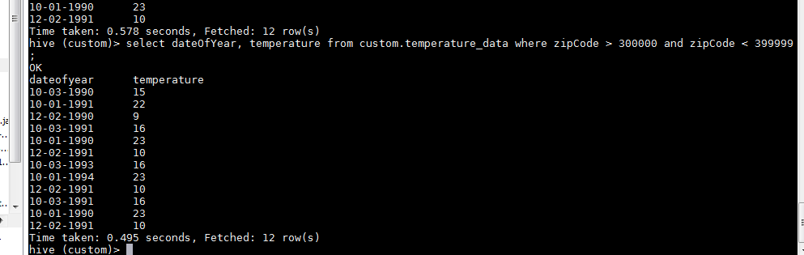

SELECT dateOfYear, MAX(temperature) FROM custom.temperature_data GROUP BY dateOfYear;

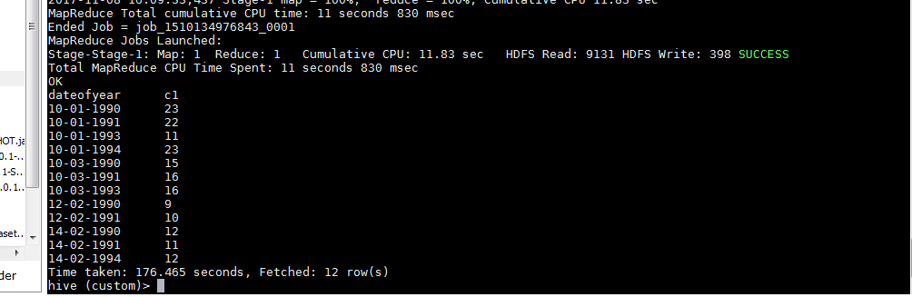

SELECT dateOfYear, MAX(temperature) FROM custom.temperature_data GROUP BY dateOfYear HAVING ( COUNT(dateOfYear) > 1 );

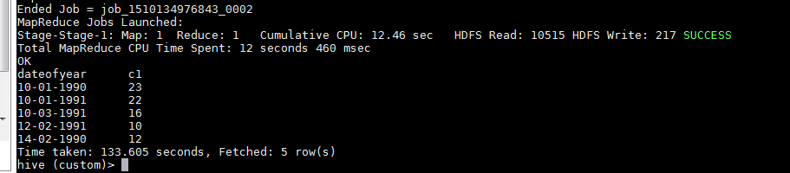

create view custom.temperature_data_vw AS SELECT dateOfYear, MAX(temperature) FROM custom.temperature_data GROUP BY dateOfYear HAVING ( COUNT(dateOfYear) > 1 );

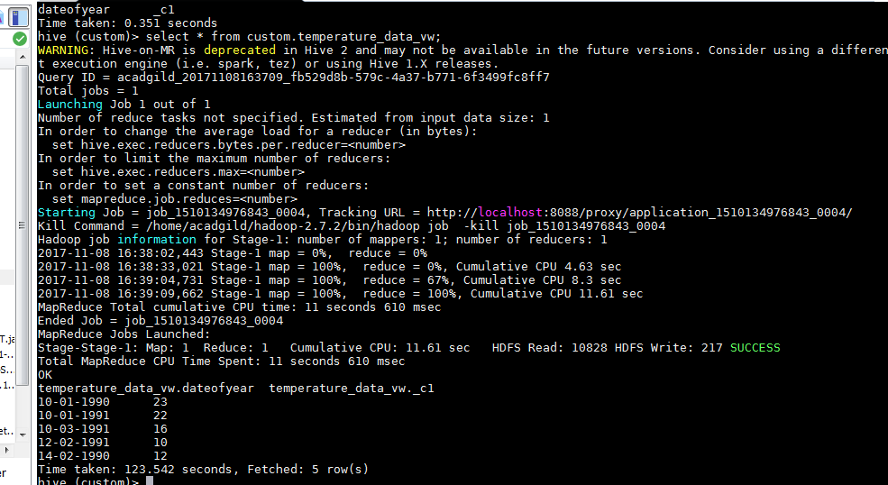

insert overwrite local directory '/home/acadgild/hadoop/maxTemp' row format delimited fields terminated by '|' select * from custom.temperature_data_vw;

